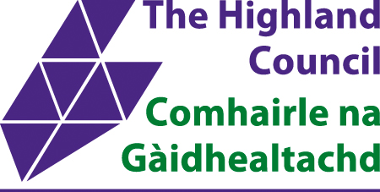
Fortrose Academy
Academy St, Fortrose IV10 8TW
STANDARDS AND QUALITY REPORT AITHISG INBHEAN IS CÀILEACHD
2024/25


School Profile
Pròifil na Sgoile

It is important to remember that statistical data alone is not a measure of how well we are doing. All schools are unique. To understand how well we are doing it is important for us to look at a range of different sources.

Fortrose Academy is located in a rural, coastal setting serving the local communities of Fortrose, Rosemarkie, Cromarty, Avoch, Culbokie, Munlochy, Tore, North Kessock, and Resolis on the Black Isle.

There are currently 646 children on the school roll. Some pupils attend following placing requests from other areas. The majority of pupils are transported to school by bus.

The Rector is supported by three Depute Rectors, seven curriculum principal teacher(s) and three Principal Teachers of Guidance and a Principal Teacher, Additional Support Needs.

Overall, attainment across the school in literacy and English and numeracy and Mathematics is very good. Children achieve appropriate CfE levels in literacy and numeracy and, across the school, a few children are exceeding nationally expected levels. Almost all children who face barriers to learning are making good progress towards meeting their individual targets. There are some important strengths however, some aspects require improvement.

More than 68% of pupils use school transport. Of our current pupils, 53% have recognised additional support needs and 8% are registered for free school meals.

Overall, attainment across the school in literacy is below our virtual comparator at level 5. English attainment is above our virtual comparator at levels 5 & 6. In terms of numeracy we are above our virtual comparator; attainment in mathematics is above our virtual comparator.

Our attainment is satisfactory and we outperform national, Northern Alliance and Highland levels. Children achieve appropriate CfE levels in literacy and numeracy and, across the school, with most children exceeding nationally expected levels. Most children who face barriers to learning are making good progress towards meeting their individual targets.

We have had 27 temporary exclusions this session involving 17 students. Exclusion is always an action of last resort, and we only take it when we think order and discipline in the school - and the education of other pupils - will be badly affected if the pupil in question continues to attend.

Data relating to our context:

 | Pupil Numbers  628 | Attendance  86.8% |  |  | Teacher Numbers  51

S1  18.9% | S2  17.2% | S3  19.6% | S4  18% | S5  16.9% | S6  9.4%

SIMD Q1  0-10% | SIMD Q2  0-10% | SIMD Q3  10-20% | SIMD Q4  80-90% | SIMD Q5  0-10% | Unknown  0-10%

ASN  50-60% | FSM  0-10% | EAL  0-10%
Glossary:
FTE – Full Time Equivalent
SIMD – Scottish Index of Multiple Deprivation
SIMD1 % pupils living in most deprived areas
SIMD5 – % pupils living in least deprived areas
ASN – Additional Support Needs
EAL – percentage of learners whom English is an Additional Language

Attainment
Literacy and Numeracy in S1-S3 – Broad General Education -
2024/2025 Proportion of pupils achieving Curriculum for Excellence Levels by the end of S3
Level 3
Reading |  | Writing |  | Listening and talking |  | Numeracy
Almost all |  | Almost all |  | Almost all |  | Almost all

Level 4
Reading |  | Writing |  | Listening and talking |  | Numeracy
Most |  | Most |  | Most |  | Most

Senior Phase

% Pupils Literacy at Levels 3 & 4 in S4 compared to Virtual Comparator/National

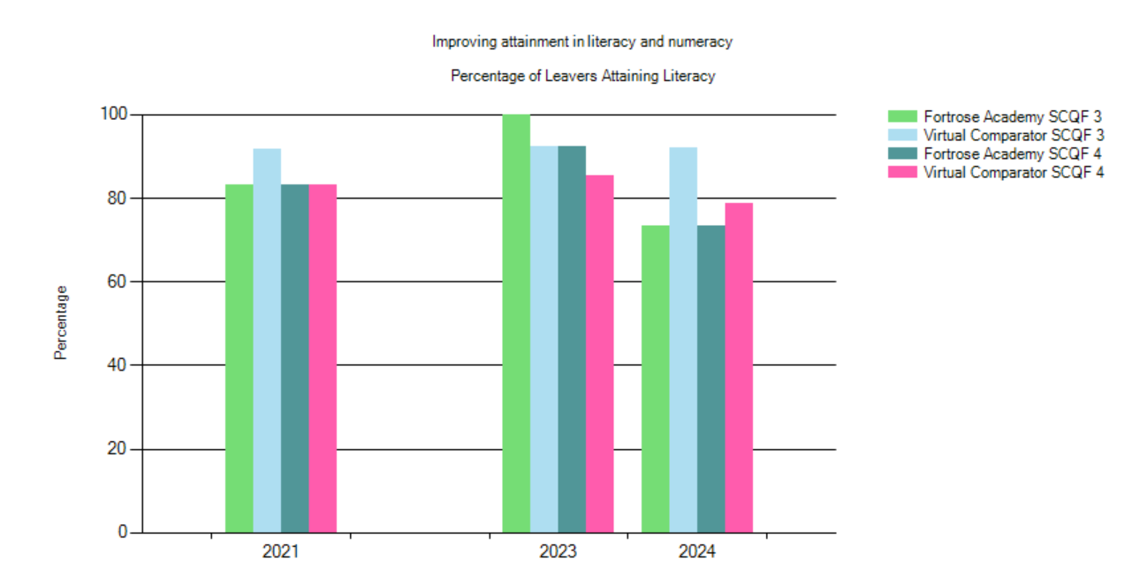

In session 2024, 15 pupils left Fortrose Academy at the end of S4. Of those 15 leavers, 11 pupils (73.33%) left with a qualification in literacy @ SCQF Level 4. The same is true for the Level 3 graph suggesting all those who achieved a qualification left with at least Level 4.

To fall in line with our Virtual Comparator for 23/24 @ SCQF Level 3, 14 of our leavers in S4 should have left with at least a Level 3 Literacy qualification. The virtual comparator has remained steady at Level 3. To fall in line with our Virtual Comparator @ SCQF Level 4, 12 of our leavers should have left with a Level 4 Literacy qualification.

A decline in pupils achieving Literacy @ SCQF Levels 3 & 4 in S4 is evident.

% Pupils Literacy at Levels 4 & 5 in S4 compared to Virtual Comparator/National
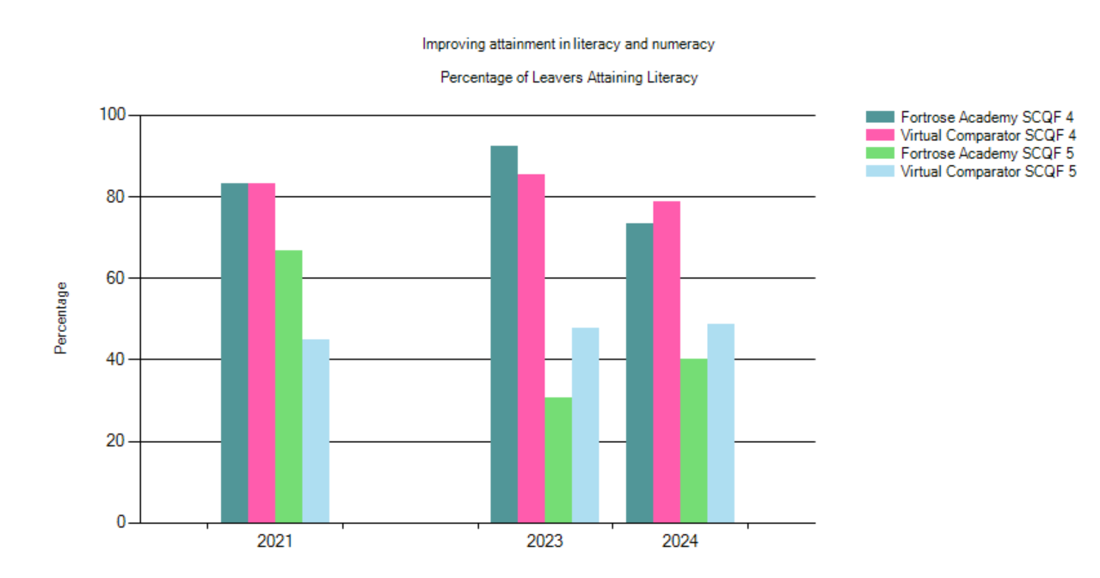
Of the 15 leavers in S4 in 2024, 6 pupils (40%) left with a Level 5 Literacy qualification. In order to outperform our Virtual Comparator, 8 pupils would need to have left the school in S4 with a Literacy qualification @ SCQF Level 5.

A 2-year trend shows a slight improvement in S4 leavers achieving a Level 5 Literacy qualification.

% Pupils Literacy at Levels 5 & 6 in S5 compared to Virtual Comparator/National
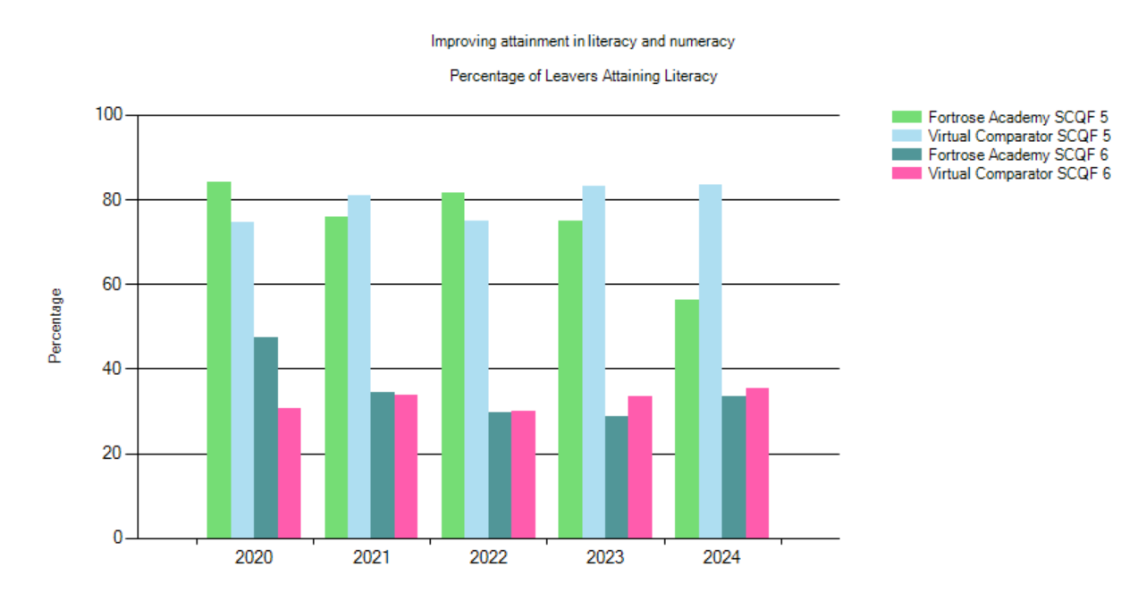

There were 39 leavers from S5 in session 2024. Of these pupils, 22 (56.41%) achieved a Level 5 Literacy qualification. In order to outperform the 2024 Virtual Comparator 33 pupils in this cohort would need to have achieved a Level 5 Literacy qualification or better.

There were 13 pupils who left after S5 who achieved a Level 6 Literacy qualification. To begin to outperform our virtual comparator, 14 pupils in this cohort would need to have achieved a Level 6 Literacy qualification.

Overall, for Level 5 & Level 6 Numeracy, there is a downward trend in the last 5 years.

% Pupils Literacy at Levels 5 & 6 in S6 compared to Virtual Comparator/National
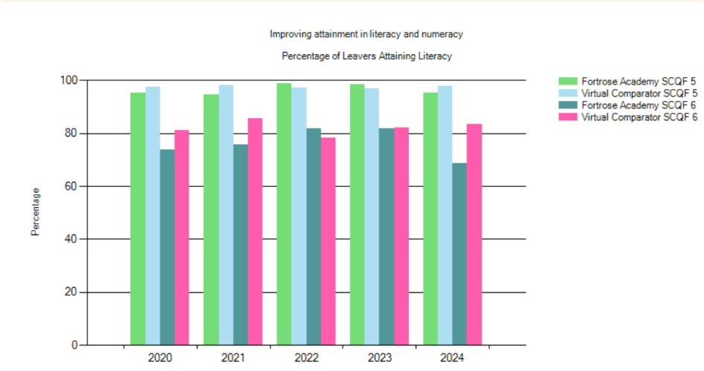

There were 83 pupils who left in S6. 79 pupils (95.18%) left with a Level 5 Literacy qualification or better. In order to outperform our virtual comparator in 2024, 82 pupils would need to have left with a Level 5 Literacy qualification.

There were 57 (68.67%) pupils who left S6 with a Level 6 Literacy qualification. In order to outperform our Virtual Comparator @ SCQF Level 6, 62 pupils would need to have achieved a Level 6 Literacy qualification.

Session 2024 was the first time in 3 years we have not outperformed our Virtual Comparator for Level 5 Literacy.

For session 2024 Level 6 Literacy was significantly lower than the Virtual Comparator and the previous 5 years.
% Pupils Numeracy at Levels 3 & 4 in S4 compared to Virtual Comparator/National

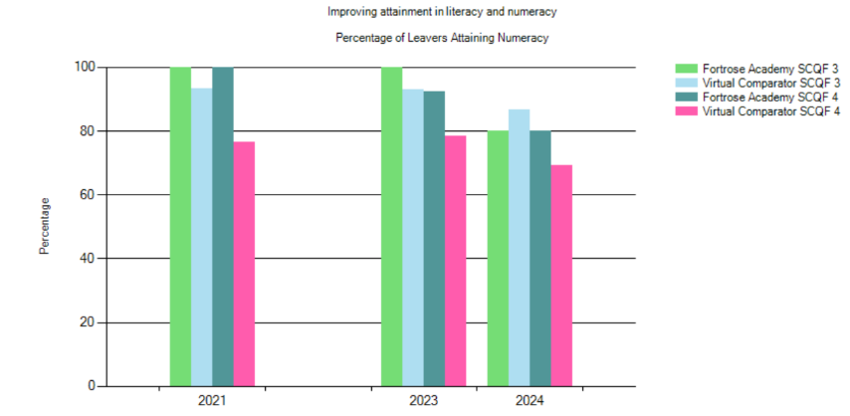

The % of leavers attaining Numeracy was below the VC this year for level 3. The % of leavers attaining numeracy at level 3 is down on 2023 & 2021.
The % of leavers attaining Numeracy is significantly higher than the VC for Level 4

% Pupils Numeracy at Levels 4 & 5 in S4 compared to Virtual Comparator/National

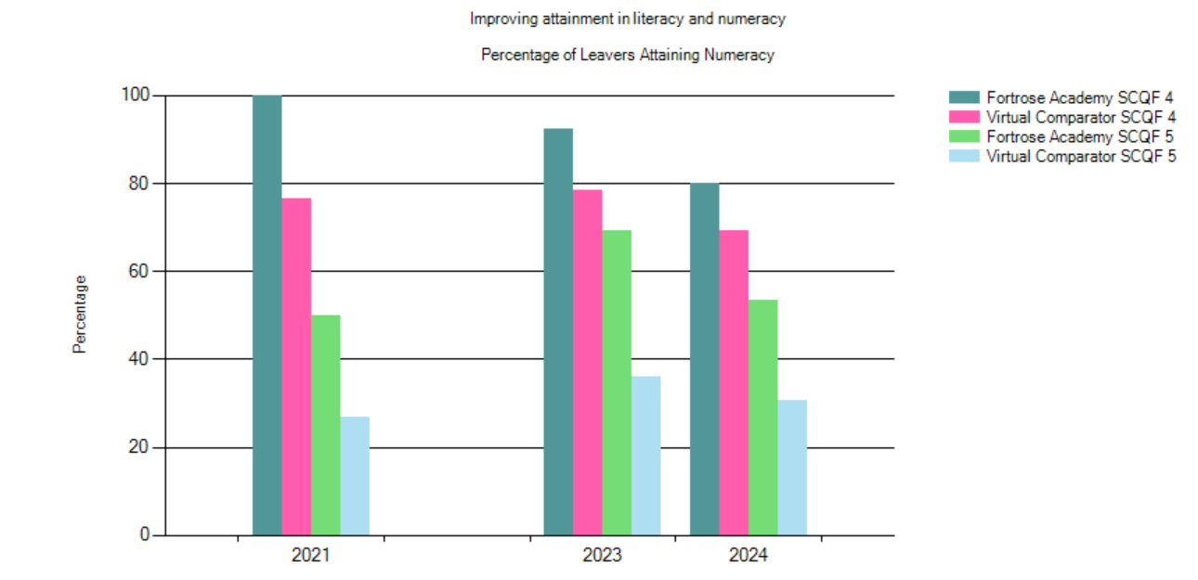

The % of leavers attaining Numeracy continues to be above the VC for Level 4
The % of leavers attaining Numeracy is significantly higher than the VC for Level 5

% Pupils Numeracy at Levels 5 & 6 in S5 compared to Virtual Comparator/National

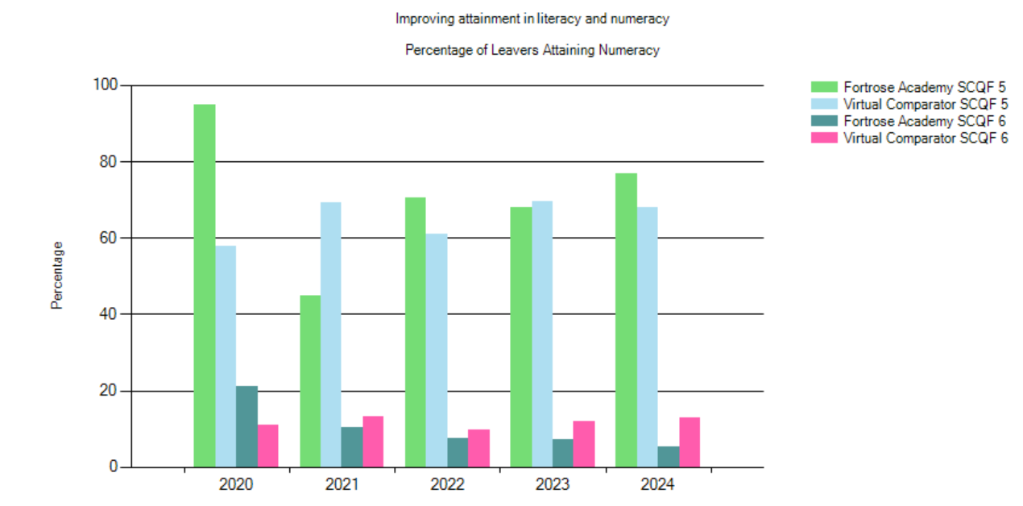
The % of leavers attaining Numeracy continues to be above the VC for Level 5. There has been a positive trend over the past 4 years.
The % of leavers attaining Numeracy is lower than the VC for Level 6. This has been a trend over the past 4 years.

% Pupils Numeracy at Levels 5 & 6 in S6 compared to Virtual Comparator/National
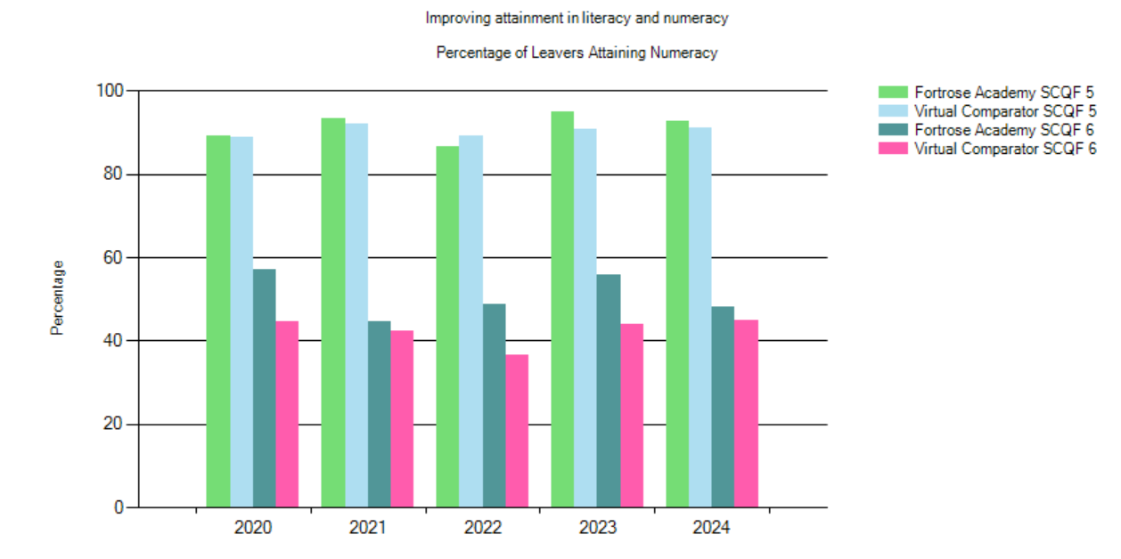
The % of leavers attaining Numeracy is higher than the VC for Level 5. The percentages are similar over the previous 4 years. The % of leavers attaining Numeracy is higher than the VC for Level 6. This has been a trend over the previous 4 years.

S4 Numeracy

Summary
Performance in Numeracy at SCQF Level 5, 2024 is greater than our Virtual Comparator
Performance in Numeracy at SCQF Level 5, 2023 is greater than our Virtual Comparator
Performance in Numeracy at SCQF Level 5, 2022 is greater than our Virtual Comparator
Performance in Numeracy at SCQF Level 4, 2021 is greater than our Virtual Comparator
Performance in Numeracy at SCQF Level 5, 2021 is greater than our Virtual Comparator
Percentage of S4 Candidates attaining Numeracy at Level 4 & 5
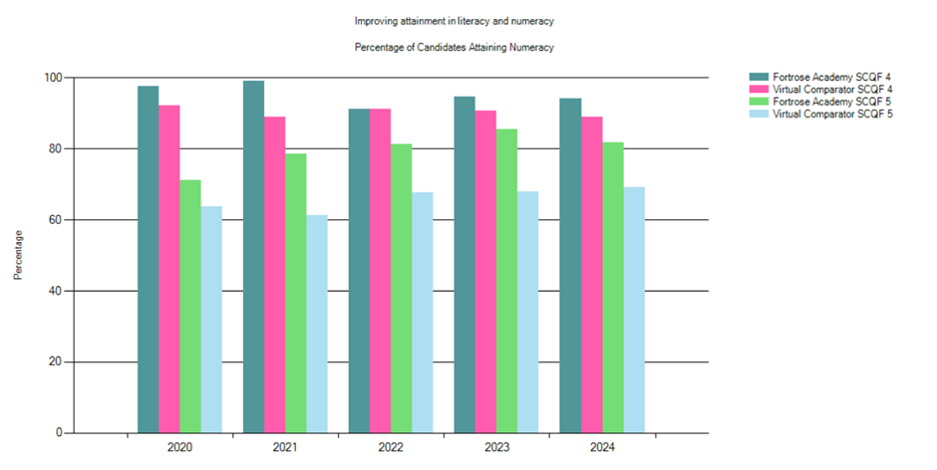
The % of pupils attaining numeracy at level 4 in S4 was higher than the virtual comparator 94.21% > 88.93%. The % of pupils attaining numeracy at level 5 in S4 was also significantly higher than the virtual comparator 81.82% > 69.26%. This has been a consistent trend over the past five years. The percentage of pupils at Fortrose Academy attaining Level 4 & Level 5 numeracy is stable. Only a small number of pupils did National 5 Apps of Maths last session.

There will be a greater impact on National 4 & 5 figures in next sessions data. Over 60 pupils have been presented for both Nat 5 Maths and Nat 5 Apps of Maths this session (76 students were presented for Apps for Maths). The department will continue to develop their knowledge and understanding of the Higher Apps of Maths course to provide continued progression for pupils in the 2026/27 session.

Percentage of Candidates in S4 with ASN attaining Level 4 & 5 Numeracy

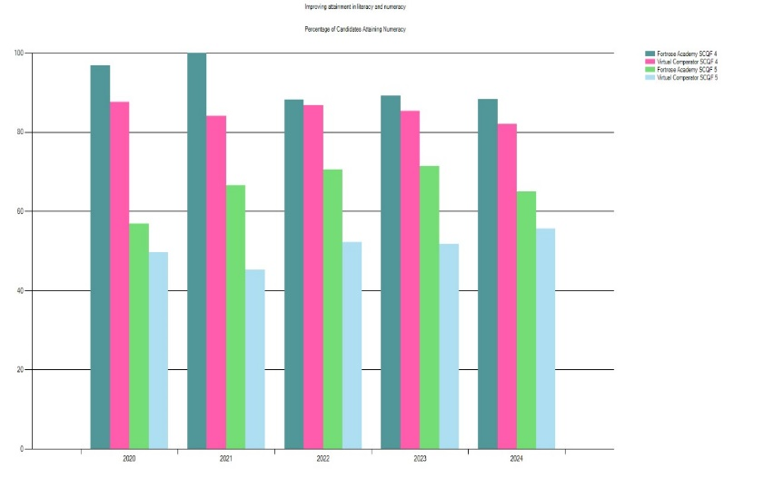

The % of pupils with ASN attaining numeracy at level 4 in S4 was higher than the virtual comparator 88.33% > 82.17%. The % of pupils with ASN attaining numeracy at level 5 in S4 was significantly higher than the virtual comparator 65% > 55.67%. This has been a consistent trend over the past five years. The percentage of pupils with ASN in S4 at Fortrose Academy attaining Level 4 & Level 5 is on a slightly downward trend.

The S4 National 5 Mathematics course comparator values have remained positive for the past five years. Four of the five years have been significant at 95% confidence levels. The course comparator value for 2024 was 1.65.
Percentage of S4 Leavers attaining Numeracy at Level 4 & 5

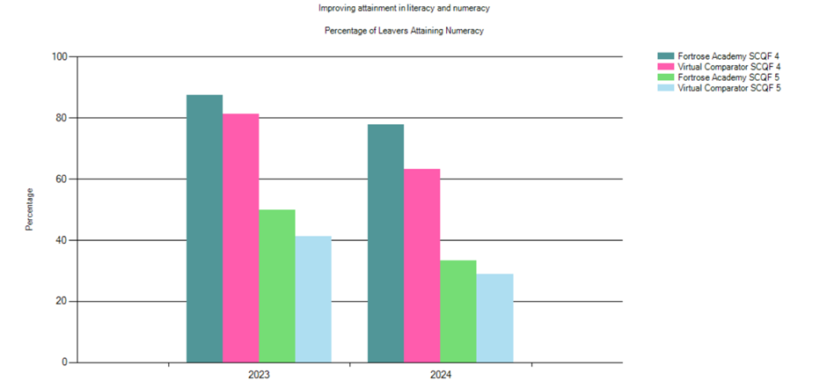
The % of pupils attaining numeracy at level 4 in the lowest 20% nationally in S4 was higher than the virtual comparator 77.88% > 63.33%. Nine in the cohort. The % of pupils attaining numeracy at level 5 in the lowest 20% nationally in S4 was higher than the virtual comparator 33.33% > 28.89%. The percentage of pupils in the lowest 20% nationally in S4 at Fortrose Academy attaining Level 4 & Level 5 is on a downward trend. This is also reflected in the virtual comparator percentages.

Percentage of Candidates in lowest 20% attaining Numeracy at Level 4 & 5

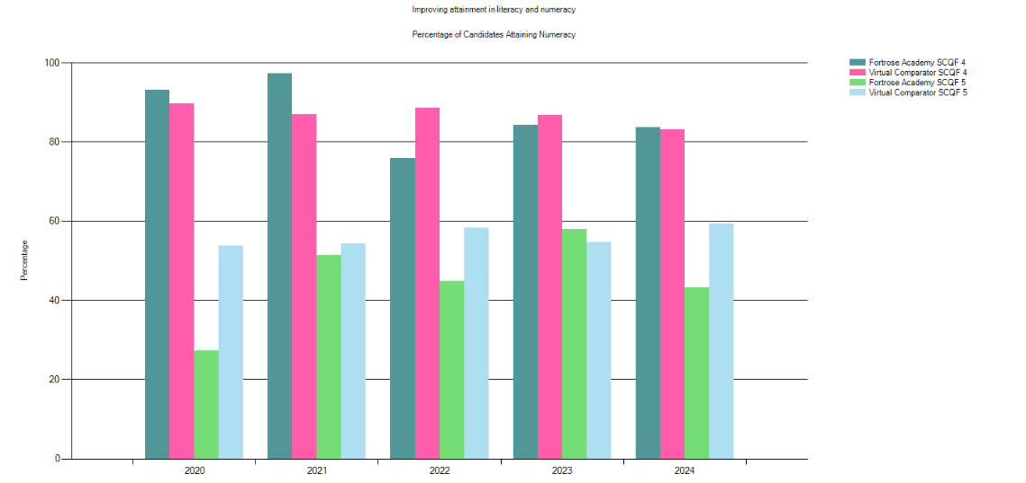

The % of pupils attaining numeracy at level 4 in the lowest 20% nationally in S4 was higher than the virtual comparator 83.78% > 83.24%. Thirty-seven in the cohort. The % of pupils attaining numeracy at level 5 in the lowest 20% nationally in S4 was lower than the virtual comparator 43.24% > 59.46%. The trend has been variable over the past five years. The percentage of pupils in the lowest 20% nationally in S4 at Fortrose Academy attaining Level 4 has been more positive in comparison to the virtual comparator. Three out of the five years have the % higher than the virtual comparator. The percentage of pupils in the lowest 20% nationally in S4 at Fortrose Academy attaining Level 5 has been consistently below the virtual comparator. Only one out of the previous five years have we surpassed the virtual comparator. The virtual comparator trend over the past five years has been stable at both Nat 4 & Nat 4 levels. The addition of Apps of Maths to the S4 curriculum will impact on these figures next session.
S5 & S6 Numeracy

Summary
Performance in Numeracy at SCQF Level 6, 2022 is greater than the Virtual Comparator
Performance in Numeracy at SCQF Level 5, 2020 is greater than the Virtual Comparator
Performance in Numeracy at SCQF Level 6, 2020 is greater than the Virtual Comparator

Percentage of S5/6 Leavers attaining Numeracy at Level 5 & 6

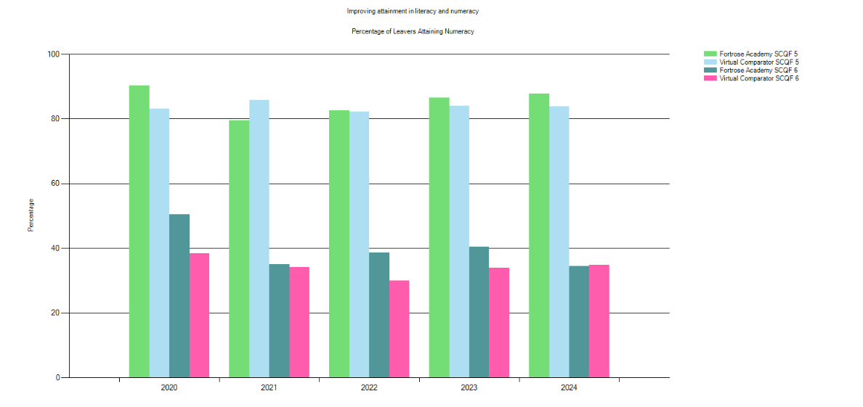

The % of pupils attaining numeracy at level 5 in S5/6 was higher than the virtual comparator 87.70% > 83.77%. The % of pupils attaining numeracy at level 6 in S5/6 was like the virtual comparator 34.43% < 34.75%. This has been a consistent trend over the past five years. The percentage of pupils at Fortrose Academy attaining Level 5 numeracy in S5/6 has been on a steady increase over the past four years. The percentage of pupils at Fortrose Academy attaining level 6 numeracy in S5/6 has been stable for the past four years and regularly above the Virtual Comparator. The virtual comparator has been stable at both levels 5 & 6 over the past five years.

Summary

Performance in Numeracy at SCQF Level 5, 2022 is greater than the Virtual Comparator
Performance in Numeracy at SCQF Level 5, 2021 is lower than the Virtual Comparator
Performance in Numeracy at SCQF Level 5, 2020 is much greater than the Virtual Comparator
Performance in Numeracy at SCQF Level 6, 2020 is greater than the Virtual Comparator

Percentage of S5/6 Candidates attaining Numeracy at Level 5 & 6

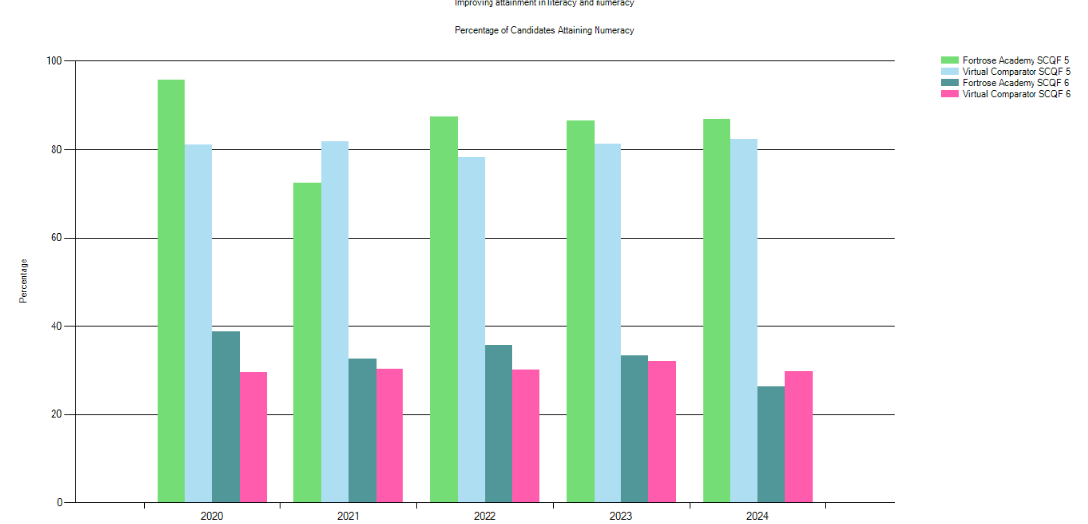

The % of pupils attaining numeracy at level 5 in S5 was higher than the virtual comparator 86.87% > 82.42%. The % of pupils attaining numeracy at level 6 in S5 was less than the virtual comparator 26.62% < 29.70%. The percentage of pupils attaining level 5 numeracy in S5 has been higher than the VC for four out of the previous five years. The percentage of pupils attaining level 6 numeracy has been higher than the VC over the previous four years. The virtual comparator has been stable at both levels for the previous five years.

Percentage of S5/6 Candidates in the Lowest 20% attaining Level 5 & 6 Numeracy

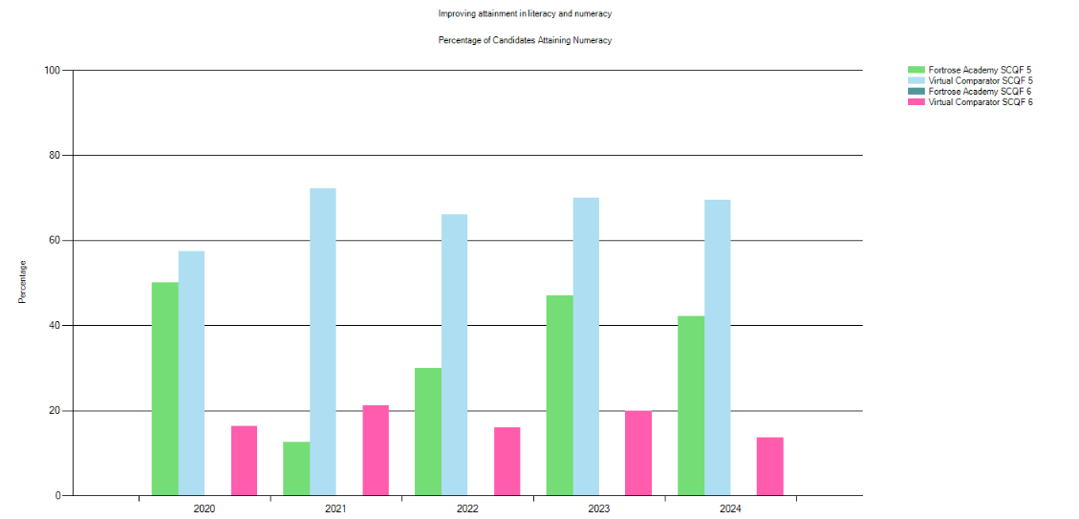

The % of pupils attaining numeracy at level 5 in the lowest 20% nationally in S5 was significantly lower than the virtual comparator 42.11 < 69.47%. Nineteen in the cohort. The % of pupils attaining numeracy at level 6 in the lowest 20% nationally in S5 has been 0% for the previous five years. The VC comparator percentage has been approximately 20% over the past five years. The virtual comparator trend has been relatively stable over the past five years. The addition of L5 apps of maths to the S5/6 curriculum will impact on these figures next session and provide a pathway from L5 apps into L6 apps of maths the following year.

Senior Phase Leavers

Percentage of School Leavers in a Positive Destination
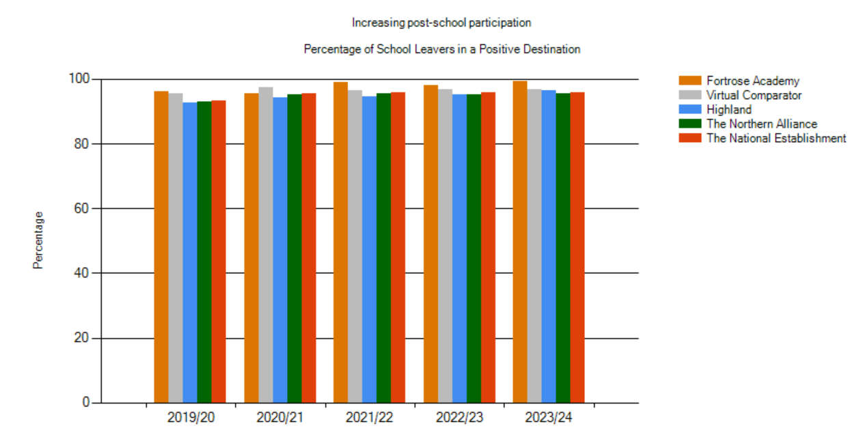
Almost all were in initial positive destinations (99.27%). This number of young people is the highest in the last 5 years. Deeper analysis has been completed to explain why so many of our leavers go into employment rather than into higher education as indicated when compared with our comparator.

Destinations of School Leavers
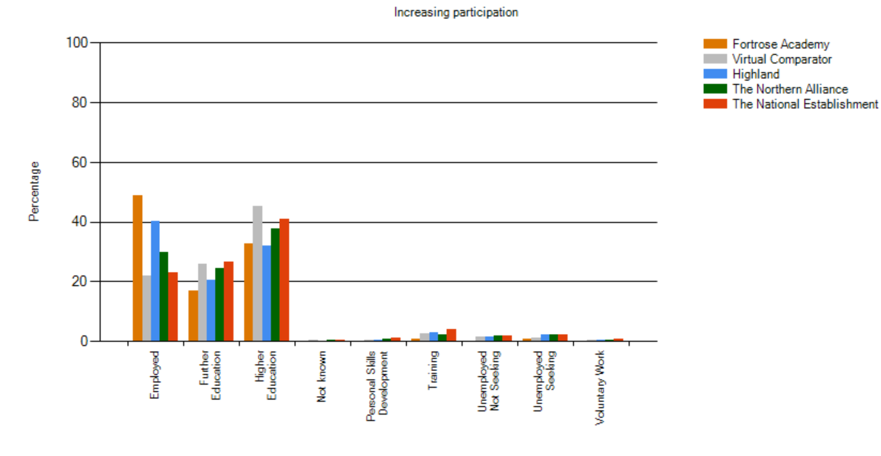
A deeper analysis into why so many pupils go on to employment after school, can be explained by a high number of pupils taking time out of education and embarking on a ‘gap year’. Our young people will frequently take time out of education to work, before going on to degree study the following year. This goes a long way to explaining the high number of young people going on to employment, and less pupils going on higher education compared to our virtual comparator.

Cohorts – Improving Attainment for All
S4
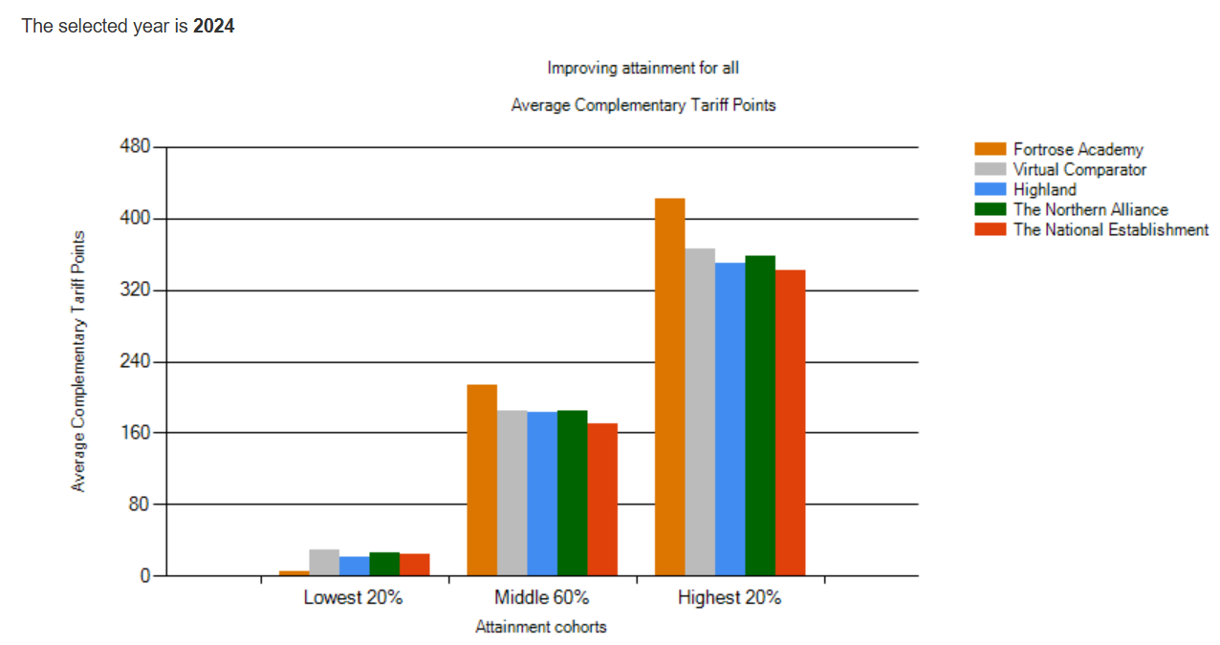
S4
For the highest 20% and middle 60% we are above the VC, however the lowest 20% attainment cohort is below the VC and other measures. For the top 20% the average complementary tariff points for Fortrose Academy was 426 compared to 366. For the middle 60% average complementary tariff points for Fortrose were 213 compared to 185 for the VC. For the lowest 20% ACTP were 6, compared to the VC with 30.

S5
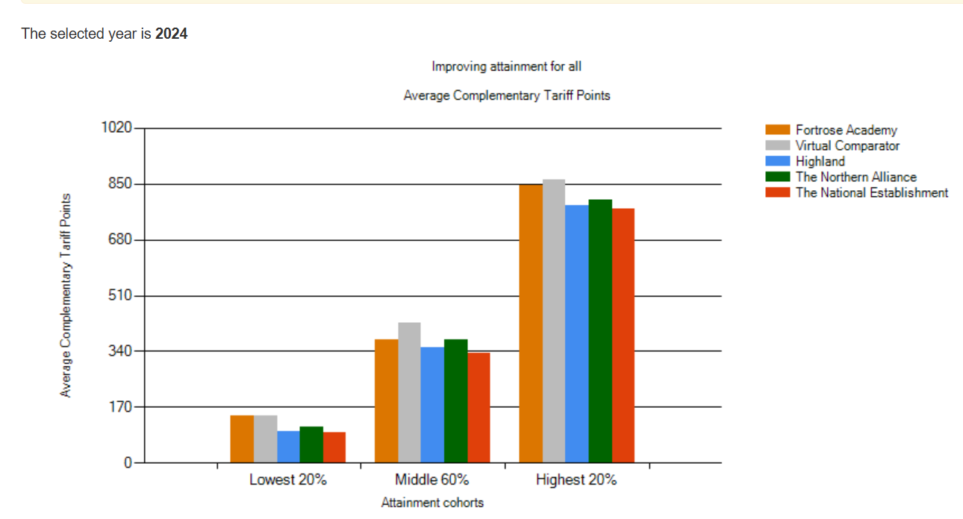
Our initial analysis suggests that pupils in S5 would benefit from the challenge of level 6 study. We find that attainment for S5 is being stifled by pupils taking a wide range of level 5 qualifications instead of exploring opportunities at level 6. The gap for our highest 20% has narrowed and is the smallest it has been in the last 4 years. The middle 60% continues to lag behind the virtual comparator. The lowest 20% improved markedly from the previous year where the gap in performance was 85 tariff points. In comparison to this year where the gap is 2 points.

S6
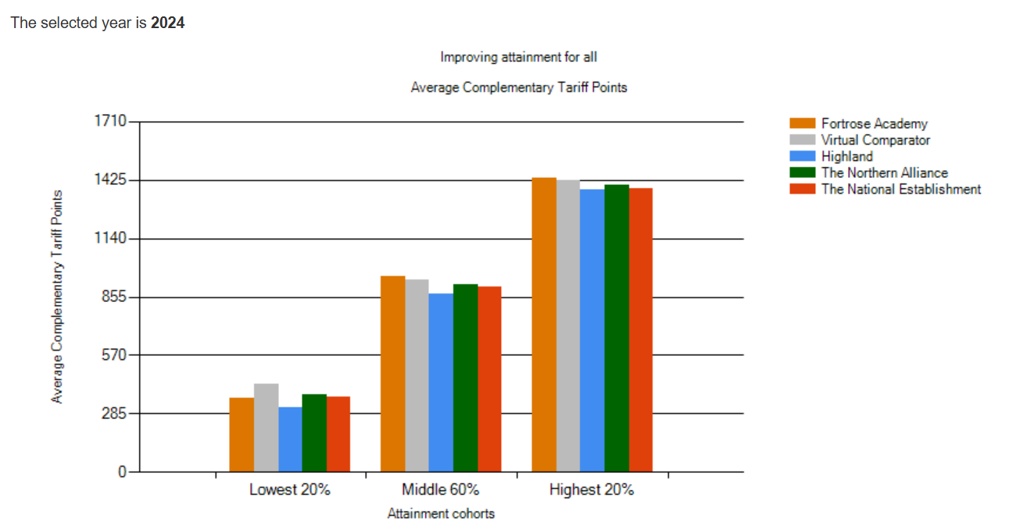
Our highest 20% continues to outperform all benchmarking measure and has done so over the last 5 years. Similarly, the middle 60% has outperformed all measures with the exception of 2022 where it was broadly in line. The gap between our lowest 20% and the virtual comparator continues to be problematic and is in fact the widest gap in the last 5 years.

ASN Attainment:

School leavers ASN pupils
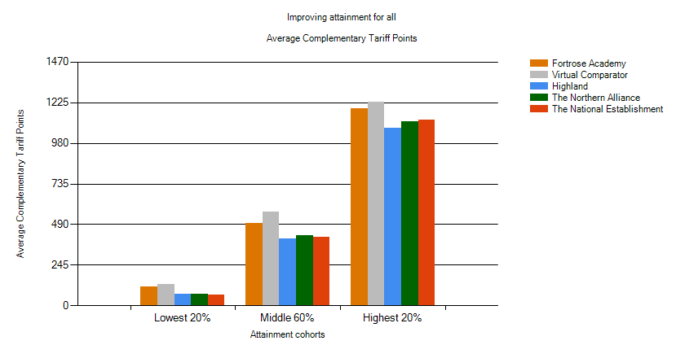
Pupils with identified ASN at Fortrose Academy significantly outperform Highland, Northern Alliance and National levels. We are however, behind our virtual comparator (VC). The largest overall gap is for our middle 60% who are 65 points behind our VC. This gap represents one National 5 qualification at grade C.

Our new curriculum model hopes to provide an extra qualification for pupils in S4 (previously 6 now 7 or 8 qualifications). This would mean at the point of exit for S4 leavers they would leave with one extra qualification. This would have a cumulative effect on leavers attainment data in S5 and S6.

S4 ASN – Pupils in S4 with identified ASN

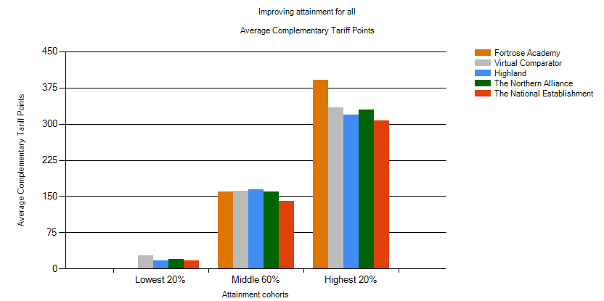

The attainment of S4 leavers with ASN is significantly higher than all other measures and the highest it has been in 5 years for the top 20% in the cohort. The middle 60% is broadly in line with the virtual comparator but significantly lower than the previous year.

S5 ASN – Pupils in S5 with identified ASN

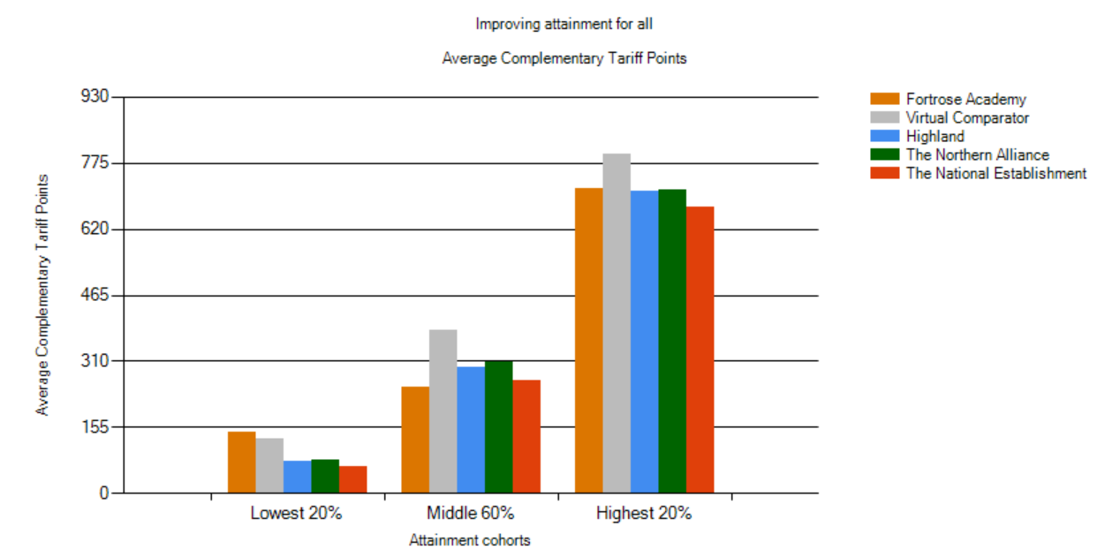Attainment for the lowest 20% with additional support needs is very significantly better than all comparative measures and is the highest it has been in 5 years.
ASN pupils in S5 are whole course awards behind VC for middle 60% and at least half a course award behind VC for top 20% at level 6.
S6 ASN -– Pupils in S6 with identified ASN
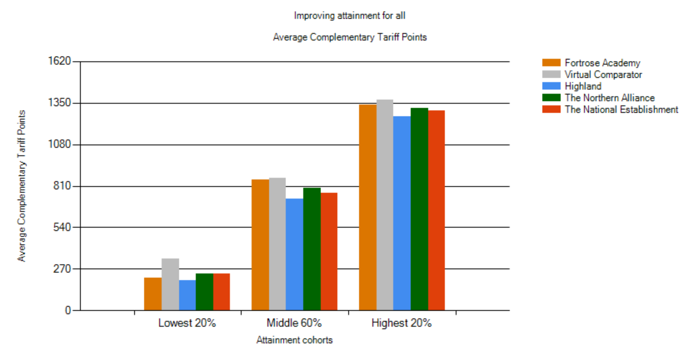Our curriculum in S6 is not capturing enough tariff points for our lowest 20%, we are one course at level 6 behind our VC.

ASN S4 – lowest 20% 5 year 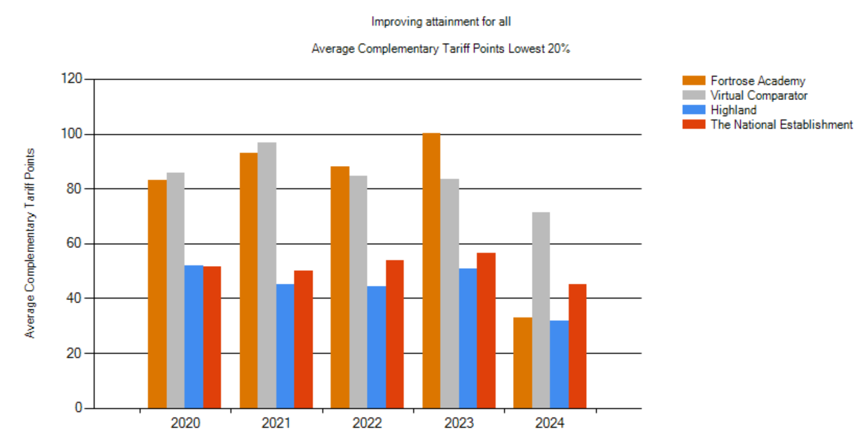
Drop of 50-70 tariff points from lowest 20% from previous years. Significant decline in presentations equivalent to 1-2 courses at level 4 per pupil.

School vision, values and aims
Lèirsinn, luachan agus amasan na sgoile

At the core of Fortrose Academy's ethos are our values: respect, unity, and ambition. We believe that instilling these values in our students is critical in preparing them for the challenges of the modern world. By promoting respect for oneself, others, and the environment, students learn the importance of empathy and understanding. Unity fosters collaboration and a sense of belonging, encouraging students to work together towards common goals. Meanwhile, ambition inspires our young people to set high standards for themselves and to strive towards their aspirations with determination.

Our vision statement, "Going Forward Together," encapsulates our commitment to collaboration and shared progress. We believe that working together — students, staff, and the wider community — empowers us to create a dynamic and supportive educational environment where every individual can flourish.

Our aims are clear and steadfast. We strive to provide an exceptional educational experience that equips students with the knowledge, skills, and attributes necessary for success. We emphasise an integrated approach to education, encouraging academic achievement alongside personal development. We aim to foster a love for learning and to nurture intellectual curiosity, enabling our students to become critical thinkers and innovative problem-solvers. Our curriculum is designed not only to meet the requirements of the Scottish curriculum but also to inspire, challenge, and engage every learner.

Our values are a key aspect of our improvement journey, and they focus on what makes Fortrose Academy a valued part of the community. We promote positivity and a collegiate approach to improvement and community engagement. Our young people are well versed in our shared values and understand their importance to their own life and the life of the school.

Our Vision: To provide high quality educational experiences that will allow our young people to thrive and achieve their full potential

Our Aims: We strive to provide an exceptional educational experience that equips students with the knowledge, skills, and attributes necessary for success

Our Values: Respect, Unity and Ambition

- Respect - we encourage our students to respect themselves and to respect the views, rights and values of others. We also expect them to respect our wider Black Isle community and to respect our unique environment.
- Unity - We are Fortrose Academy. We Support each other; Work together and Everyone matters. We aim for our school to be fully embedded in the heart of the Black Isle and all of its communities. We encourage our young people to have pride in their school. We will consider the rights of others and accept and value diversity. A key focus is to work together as a community, to form and maintain strong community links and deliver for the common good of all.
- Ambition - all of our young people will be ambitious for the future. We wish them to develop self-esteem, self-confidence and resilience. We are ambitious for our young people and strive to give them a high-quality education and a positive destination. We encourage our students to aim high; to reach or exceed their potential and to know success is theirs to take if they work hard.
Review of progress of improvement plan projects for session 2024/25
Ath-sgrùdadh air adhartas airson an t-seisein

These projects are linked to the priorities for Scottish Education based on the National Improvement Framework aimed to deliver excellence and equity. Parent/Carer information is available here.

School Improvement Plan Priority 1
Q.I. 1.3, Leadership of Change - Develop and embed the impact of our values within our school community.
Summary of impact | Next steps
- Explicit reference to school values in assembly programme across the year  - Whole school policies have been updated that more closely align to our school values  - New House system launched  - Students reported respectful classroom environments (69% in S1, 76% in S2, 97% in S3)  - Students feel encouraged to do their best (88% in S1, 94% in S2, 85% in S3)  Good progress has been made in this area | - Carry over Google Form survey  - Carry over significant number of lesson observations/audit of faculty resources

School Improvement Plan Priority 2
Q.I. 3.1 Ensuring Wellbeing, Equality & Inclusion: Support wellbeing across the school community through the implementation of key projects.
Summary of impact | Next steps
- Rights Respecting Schools training at Bronze level completed.  - Steering Group of staff and pupils formed  - Mentors in Violence Prevention: pupils led by assemblies/delivered in lessons  - Sessions delivered to address bystander effect and reduce incidences of violence and aggression  - EmpowHer girls group set up and 2 staff trained to deliver Get Set resources  - Black Isle Brewery – HWB focus on working outside  - Increased attendance  - Volunteering at Munlochy Animal Aid – HWB focus – walking dogs  - Introduction of a Soft Start in the Oasis for pupils  - Targeted tutorial groups started to support pupils with EBSA (practical activities = gardening, supported walks, baking.  - Individualised curriculums for targeted pupils with EBSA/SEBN  - Increased attendance  Good progress was made in this area | - Working towards achieving Gold status (Silver status achieved June 2025)  - Lessons delivered to A.S.G. primaries  - Additional girls’ groups to be established  - Revalidation Gold Schools Sports Award  - Nurture provision to be established in the school.

School Improvement Plan Priority 3
QI 2.2 Curriculum: - Embed curriculum restructure and personalise to include opportunities for engaging with employers.
Summary of impact | Next steps
- Curricular Review December 2024  - Introduction of Curriculum Meetings with Principal Teachers to discuss Senior Phase offer.  - Introduction of early intervention literacy & numeracy strategy.  - Introduction of new raft of qualifications into the Senior Phase:  SCQF Level 5 Furniture Making (NPA)  Level 4&5 Scottish Studies Award  SfW Laboratory Skills  NPA Level 5 Media  NPA Digital Skills Level 3  - ASN department wider achievement qualifications:  Young Enterprise Award  Dynamic Youth Awards  Digital Literacy Award  - Careers Fayre February 2025  - Embedding SDS Skills Workshop September 2024  We have made Satisfactory progress in this area | - Curricular Review to continue  - B.G.E. Curriculum Review  - Refreshed Fortrose Academy Curriculum Rationale  - Define ‘core experiences’ for pupils in BGE. Linked to local context.  - Employer Mock Interviews  - Establishing a farming/rural pathway  - Introduction of NPA Tenancy, Enterprise & Employability, Leadership & Volunteering, through the ASN department to meet the needs of the lowest 20%  - Employability and Mental Health Awards through PSE curriculum

School Improvement Plan Priority 4
Q.I. 2.3 Learning, Teaching & Assessment – Develop learning and teaching strategies as identified through self-reflection
Summary of impact | Next steps
- Satisfactory progress made to improve the quality of learning, teaching & assessment, almost all staff engaged in training on differentiation/adaptive teaching and use of AI (TeachMate) through specific CPD whole staff meetings. Feedback from survey of S1-3 identifies a range of adaptive strategies used in some lessons and focus groups – students access one-to-one support (64% in S1, 74% in S2, 85% in S3), help sheets (24% in S1, 15% in S2, 26% in S3), word banks used (12% in S1, 10% in S2 & S3) and teachers adapted questions for greater understanding (64% in S1, 38% in S2, 62% in S3).  - The Learning, Teaching & Assessment Group (LTAG) ran a CPD carousel (Feb inset), including sessions on interpreting new NSA data, improving feedback, what’s new in Google & refresh of google forms to collect student feedback, introduction to coaching conversations and refresh co-operative learning. On feedback, student comments suggest quality feedback in most classes ‘you know what you can work on next time’ and ‘definitely improves your understanding’, however, students stated that too much feedback can be overwhelming and comments such as ‘the teacher says if you did good or not, but not how you lost marks or how to get more marks’.  - Most students reported that they understood what they were learning and why (87% in S1, 79% in S2, 76% in S3)  - Most students reported that they understood what they needed to do to achieve success in their work (84% in S1, 88% in S2, 91% in S3)  - PTs/Faculty Heads and LTAG consulted on refreshed lesson evaluation process and new lesson evaluation feedback forms shared. Staff positive about the use of examples from School Inspection Findings where schools have achieved Very Good or Excellent for QI 2.3. Modifications to be made to allow whole lesson evaluations.  - Very good progress in student engagement with Achieve with 5731 visits and 98087 questions answered in the last year. Fortrose Academy has been selected to pilot AI feature for next session in selected subjects  - LTAG started refresh of Super6Skills school poster: new clearer descriptions of skills created, and a format agreed following staff consultation  - LTAG introduced Northern Alliance Learning & Teaching toolkit to all staff Sept 24  - The data hub was refreshed with Primary ACEL data added and new resources to explain changes to NSA data. NSA visit in Nov commented on the good practice and the high % of completion at Fortrose Academy enabling staff to be more informed about learners  Overall, we think we have made good progress in this area. | - To focus on specific feedback strategies  - Embed the use of TeachMate AI to improve learning & teaching  - Implement the Fortrose Framework – a lesson structure  - Embed the use of the resources on the Northern Alliance Learning & Teaching toolkit into teacher/department practice  - Refocus on Super6Skills  - Implement Achieve AI pupil feedback on marking feature with English, Geography, History and Business departments

Progress and impact of Pupil Equity Fund
Adhartas agus buaidh Maoin Cothromas Sgoilearan

Maths/Numeracy impact:

Numeracy Recovery Aim was to maximise support by identifying eligible P7 pupils via teachers and SNSA results and baseline assessment who can start with 1:1 interventions from the start of S1. Also, to continue to develop PSAs’ skills in the delivery of 1:1 resources to maximise interventions.

Baseline assessments have been developed to track progress at the beginning and end of the year. Gaps in baseline assessments have been identified to pinpoint ongoing targeted support. Engaged with maths staff to identify termly topic work to ensure MyMaths activities are appropriate to support current learning in class.

In S2 and S3, Numeracy Recovery Continued with targeted 1:1 support at the beginning of each term. Gaps in baseline assessments had been identified to pinpoint ongoing targeted support.

Of the 22 pupils accessing numeracy support through the PEF funding; 19/22 improved by at least 2 skills, at most 15 skills with an average skills development of 9.5 skills.

Literacy impact: The Literacy PEF project supported 41 pupils with reading. Of the 41 pupils supported; 24 made improvements in reading age of at least 1 year, one pupil improved reading age by 5 years and of the 24 pupils who improved, there was an average improvement in reading age of 2.4 years.

Wider achievements
Coileanaidhean nas fharsainge

We continue to provide a raft of wider achievement opportunities for our young people:
- UHI Step into Drama Programme
- Fortrose Academy Sponsored Walk
- Intergenerational Mix & Mingle (including Christmas Lunch & meals on wheels gift bags)
- Intergenerational – Getting to know your Techno, Building Relationships & Tackling Loneliness
- Community Cafe (in Partnership with For You Training & Black Isle Cares)
- Young Enterprise (Students achieved Level 6 Enterprise Award) UK Winners
- Future Assets
- Mentor in Violence Prevention (MVP) S5-6 pupils
- Pupil input into the Swedish delegate visit around GIRFEC
- Girls Group EmpowHer
- Kings Trust (wider achievement award)
- NPA Digital Literacy Level 3
- STEM Leaders
- Duke of Edinburgh
- Ross County PDP

Our Youth Development Officers continue to contribute significantly to the wider achievements in school:
- Resilient Kids – Moving Up Programme
- Highlife Highland Leadership Awards
- Highlife Highland Young Leaders #Beethechange campaign in partnership with Mikeysline
- Saltire Awards
- Food Hygiene Awards
- Pupil led support of MFR Mission Christmas
- Pupil involvement in community organisations (e.g. Community Council, Sport Scotland Ambassadors, Youthwork lunchtime sessions)
- Pupil involvement in Rowing Worlds in Stranraer
- Resilient Kids

Our school is proud to provide opportunities for young people to play sports at all ages including:
- Football
- Rugby
- Golf
- PE
- Hockey
- Orienteering
- Netball
- Basketball
- Swimming
- Cross Country

Our school has led a variety of trips to support our pupils achievements across the four contexts:
- Belgium History Trip
- Modern Studies Trip to Scottish Parliament
- Claviere Ski Trip
- Scottish Rugby School Trips to Murrayfield
- Culloden Battlefield
- Mock Cop
- RHET Farming Visits
- Horse Riding Group
- Monsterfest 2024
- German Trip to Highland Wildlife Park
Comments from learners, families, stakeholders and staff
Beachdan bho luchd-ionnsachaidh, teaghlaichean, luchd-ùidhe is luchd-obrach

How do we know that everyone is treated fairly and with respect in our school?
Teachers make sure everyone is treated fairly. Other pupils make sure others are ok. Equal opportunities for people to do stuff outside of school. Almost all, 91% of students in S1-3 stated they were treated fairly in lessons.
Parents commented that the P7 information evening was excellent, very informative and very reassuring for parents. It was commented ‘if the atmosphere here tonight is indicative of the experience that our young people are having, then it is a good experience.’
Examples of feedback from parents on reports:
“The addition of detailed teachers’ comments are very gratefully received, especially at this stage of secondary school.”
“Thanks for the really constructive feedback, I value the time and effort the teachers have put into their helpful and specific responses.”
“An excellent report, very proud of him. A big thank you to all his teachers who have helped him have such a positive start to his time at Fortrose Academy, we really do appreciate it.”

How are your efforts to do well recognised by staff in our school? How does our school help you to feel good about yourself?
Certificates. Display our trophies. Free time in classes. Awards ceremonies. Use social media. Move up in English and Maths. Scientist of the month. Praise in lessons.

Capacity for continuous improvement
Comas airson leasachadh leantainneach

Using indicators from ‘How Good is our School 4’ together with learner, parent, carer, partner and community feedback we believe we have made progress as follows:

 | 2024-2025
QI 1.3 Leadership of change | Good
QI 2.3 Learning, Teaching and Assessment | Good
QI 3.1 Ensuring Wellbeing, Equality and Inclusion | Good
QI 3.2 Raising attainment and Achievement | Satisfactory
Other QIs reviewed | N/A

Our overall evaluation of our capacity for continuous improvement is:
We are confident in our capacity for continous improvement.

Key priorities for improvement planning
Prìomhachasan airson planadh airson leasachadh

Planning ahead
A’ planadh air adhart

Full details of the school’s 2025/26 improvement priorities and actions are detailed on the school improvement plan, which can be accessed on our website https://www.fortroseacademy.co.uk/ or by contacting the school office.

In this report the following words are used to describe the numbers and proportions used:

All | Almost all | Most | Majority | Less than half | Few
100% | 91% - 99% | 76% - 90% | 51% - 75% | 16% - 50% | Up to 15%

